1. Introduction
   1. Overview

Subscribers Galore: Exploring the World's Top YouTube Channels" is an engaging and informative multimedia project that delves into the fascinating world of YouTube's most popular and influential channels. This project aims to provide an in-depth look at these channels, the creators behind them, and the secrets to their success. It will showcase the diversity of content, creativity, and strategies that have propelled these channels to the top of the YouTube ecosystem.

* 1. Purpose
* The profiles and interviews with successful YouTube creators can serve as a source of inspiration for those looking to start their own YouTube channels. It can demonstrate that with dedication and creativity, anyone can find success on the platform.
* Marketers and advertisers can learn from this project by studying the content, engagement, and monetization strategies of top YouTube channels. This can inform their own advertising and partnership decisions.
* The project can provide insights into how YouTube channels adapt to changing trends and technologies, which can be beneficial for content creators, marketers, and innovators seeking to stay at the forefront of online content.

you can achieve a deeper understanding of the YouTube platform, content creation, and the strategies used by top channels. It can empower content creators to improve their content and grow their channels, educate marketers about effective advertising and sponsorship opportunities, and inform the broader public about the evolving landscape of online media and its impact on society and culture. Ultimately, it provides a comprehensive view of how these top YouTube channels have achieved their success and how others can learn from their journeys.

1. Problem Definition and Design Thinking
   1. Empathy Map

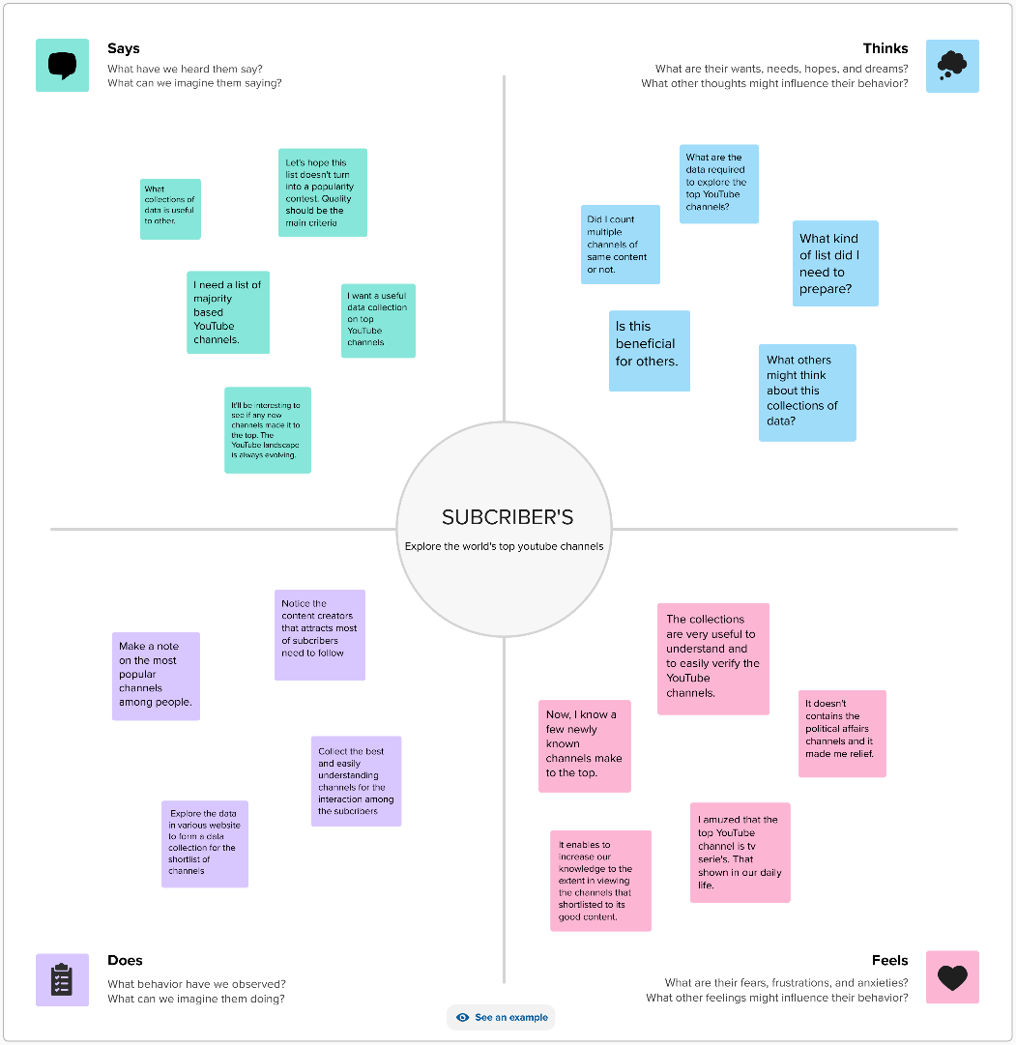

* 1. Ideations & Brainstroming Map

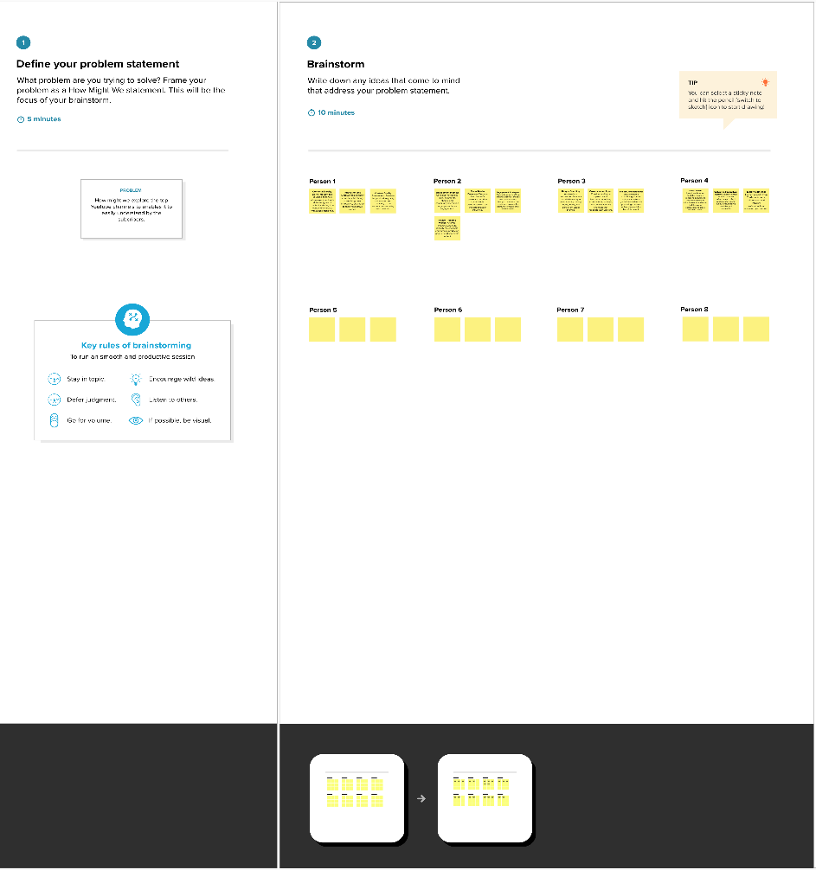

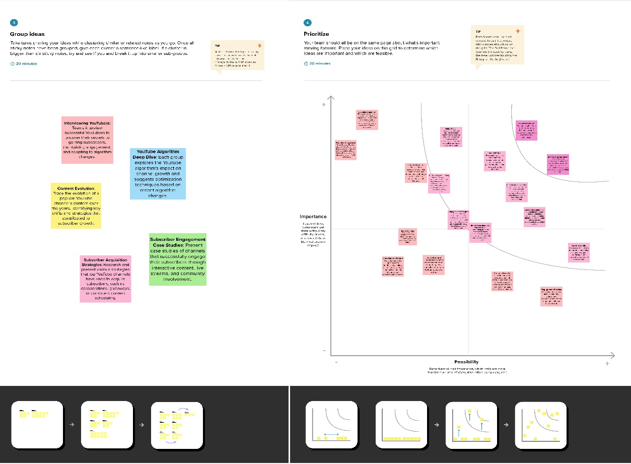

1. Result
   1. Final Outputs

* Dashboard 1
* Table shows Rank wish channel.
* Bar graph shows the number of channels with Brand.
* Table shows Brand.

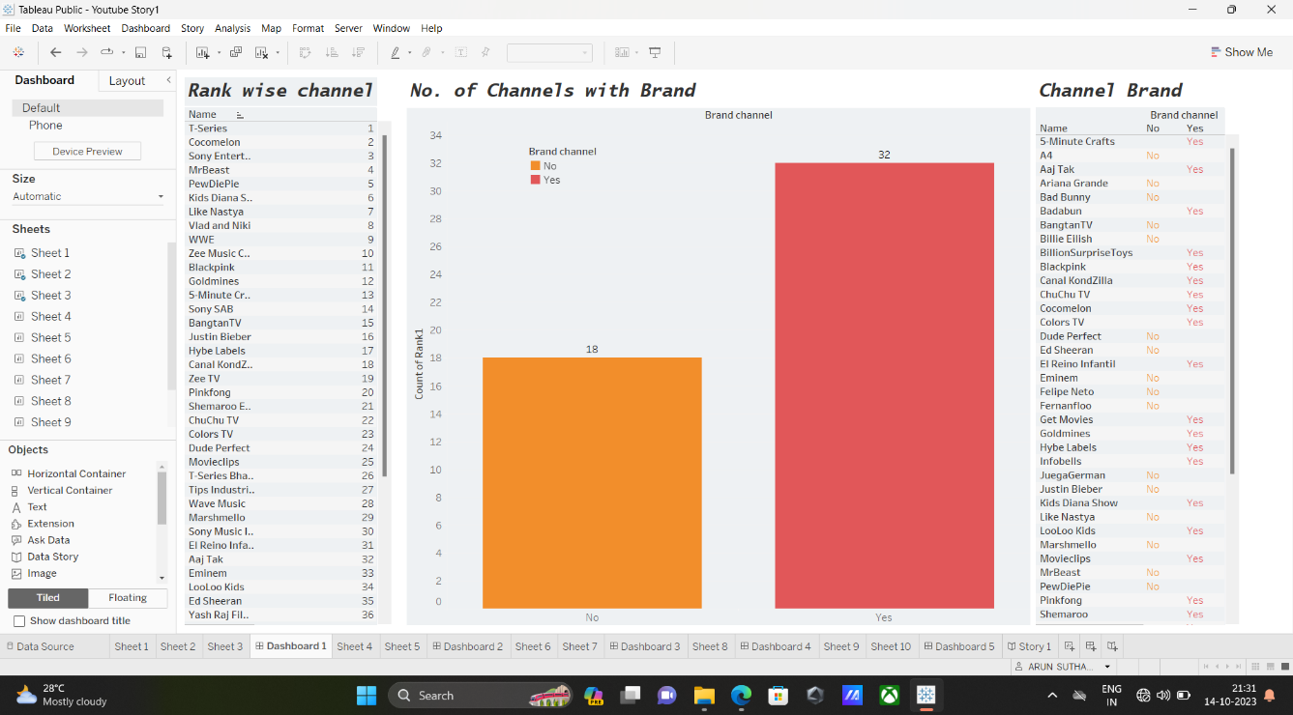

* Dashboard 2
* Heatmap shows channel name with subscribers.
* Circle shows a number of channels with a particular language.

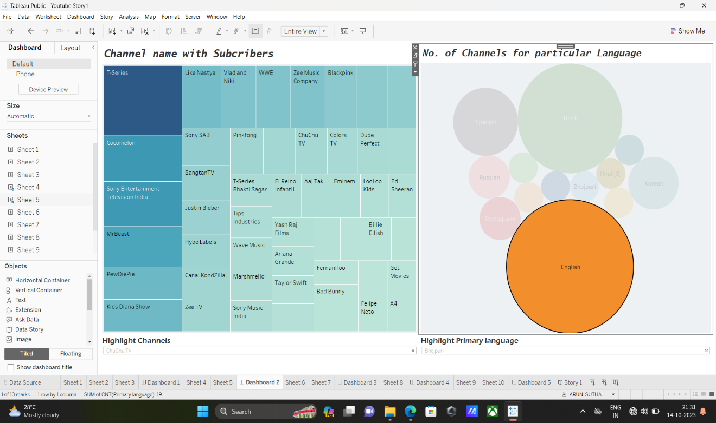

* Dashboard 3
  + Bar graph shows category wise language.
  + Bar graph shows the Country with its primary language and number of subscribers.

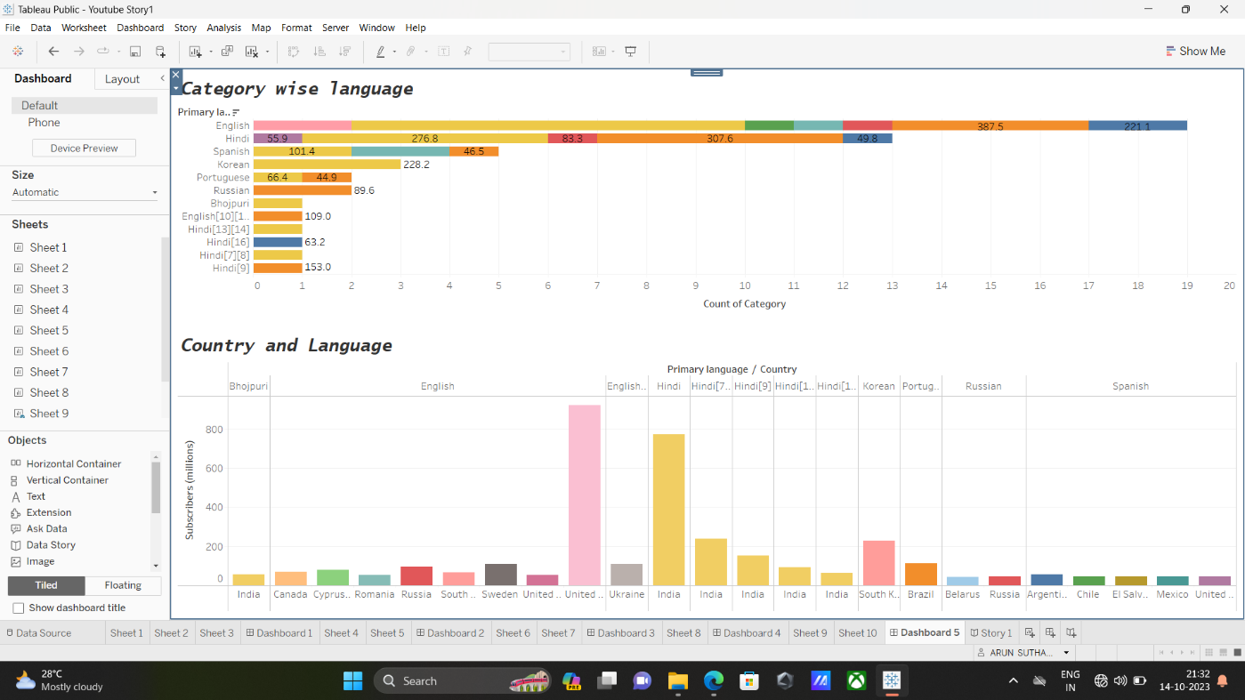

* Dashboard 4
  + Bar graph shows language wise subscribers.
  + Bar graph shows country wise subscribers.

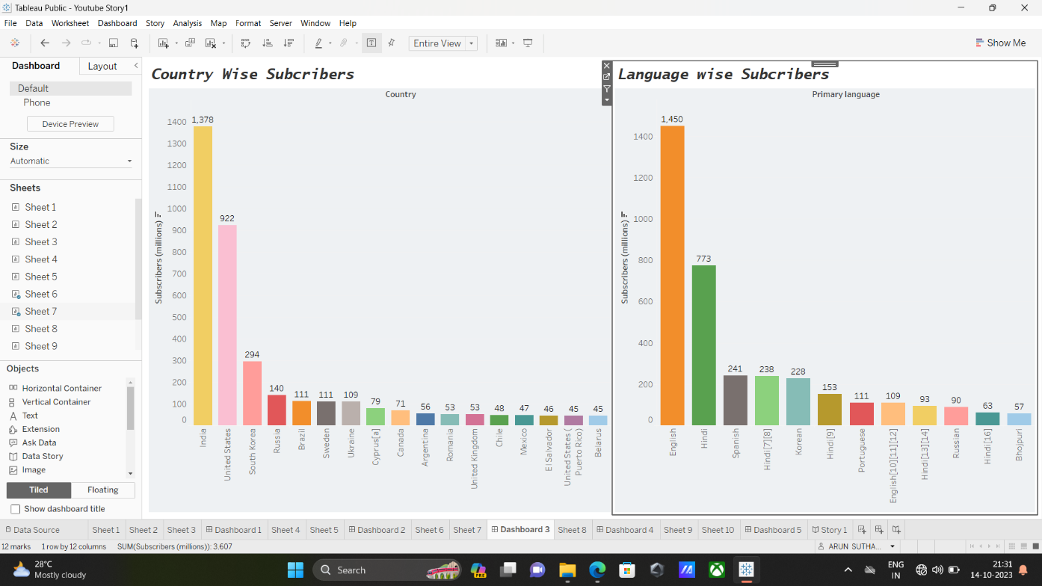

* Dashboard 5
* World map showing Country wise channel.

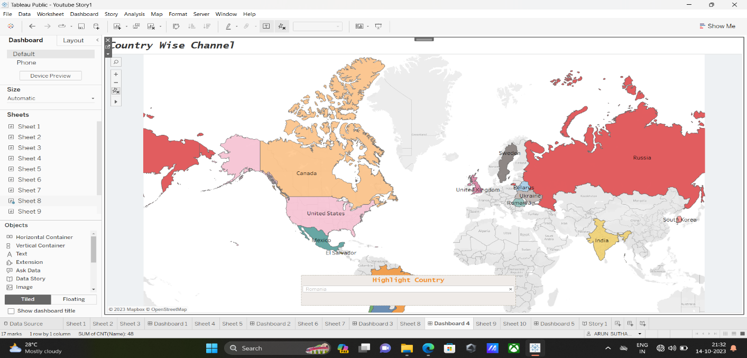

* Story

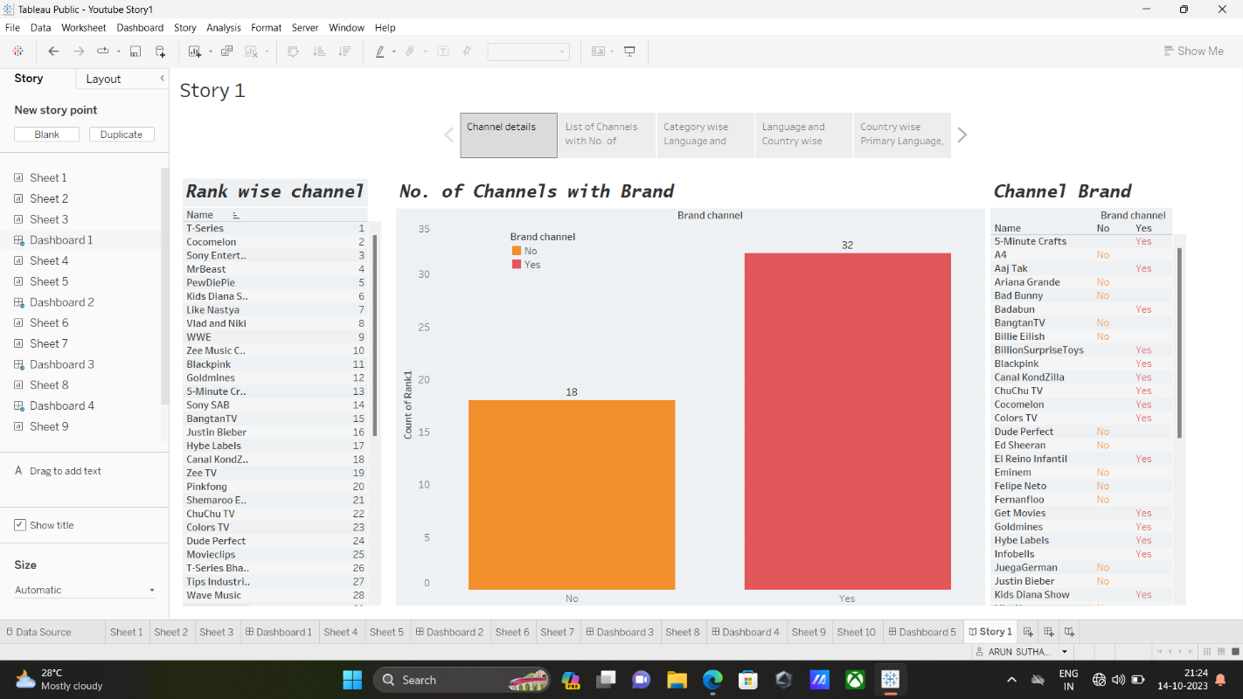 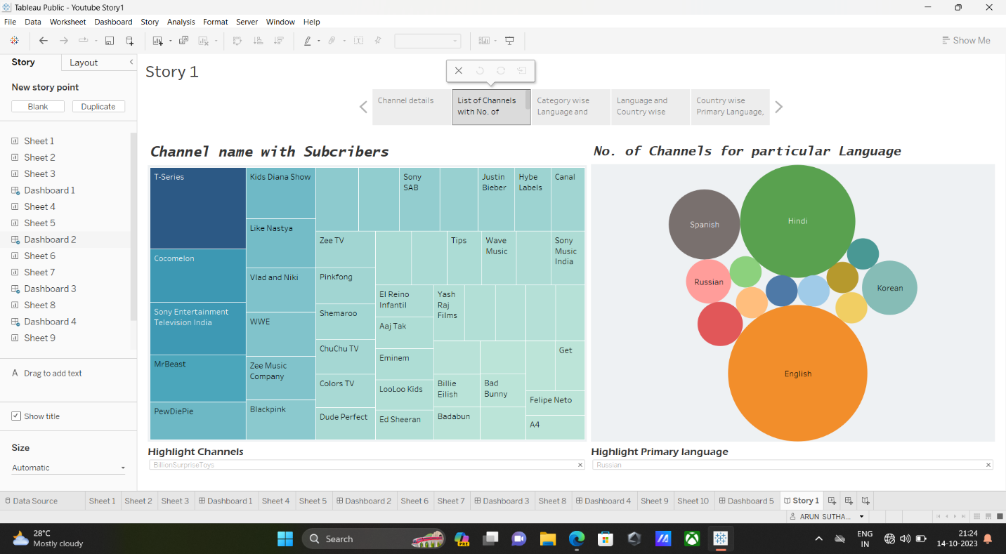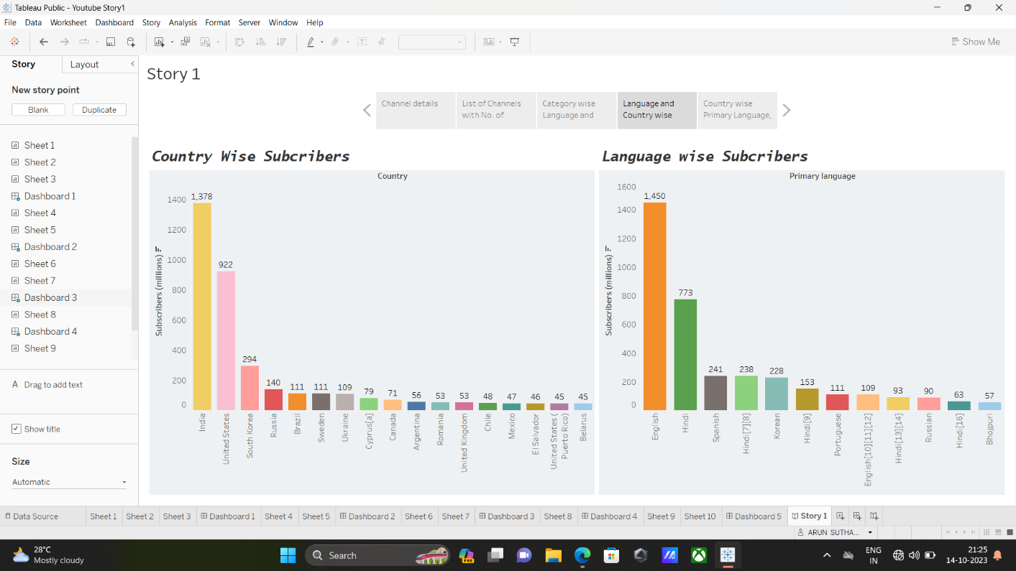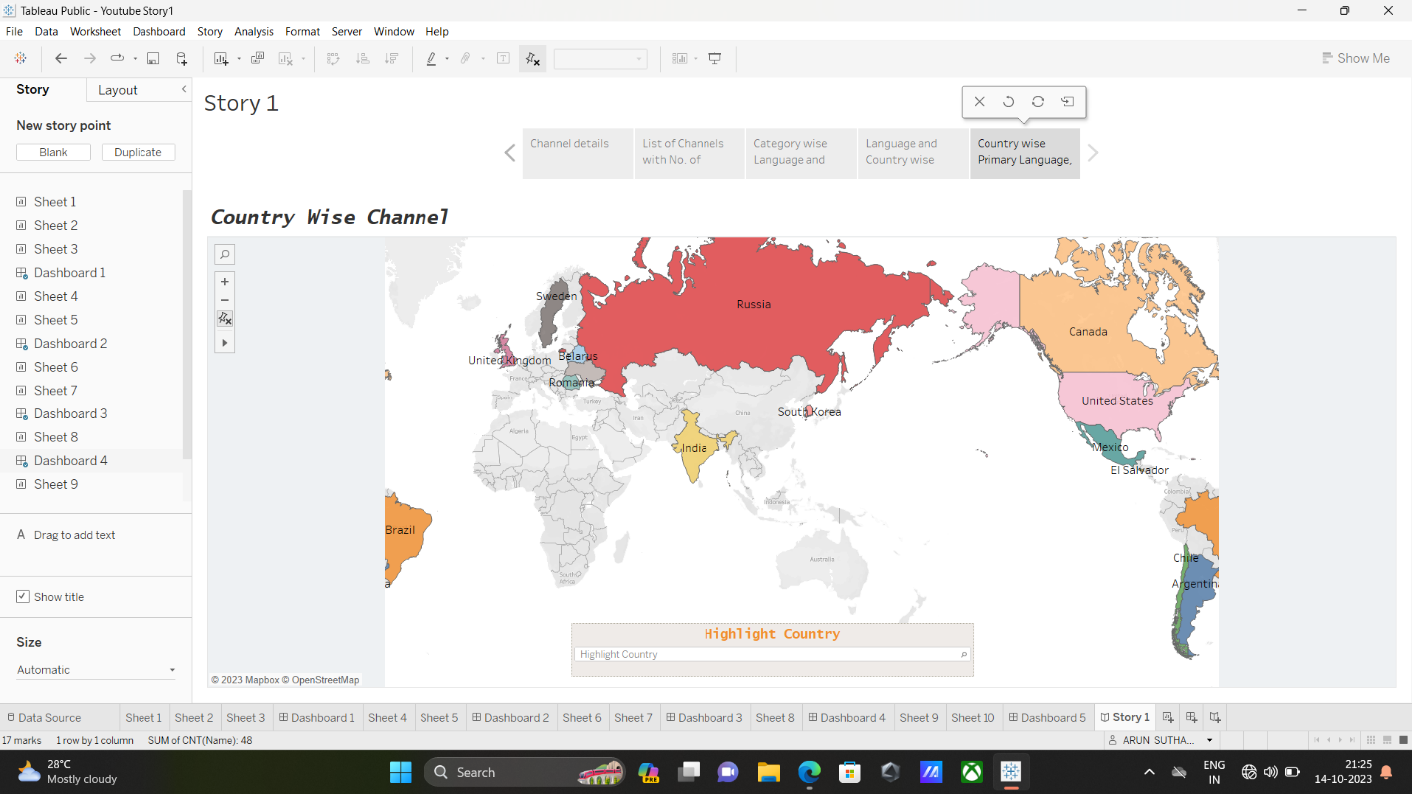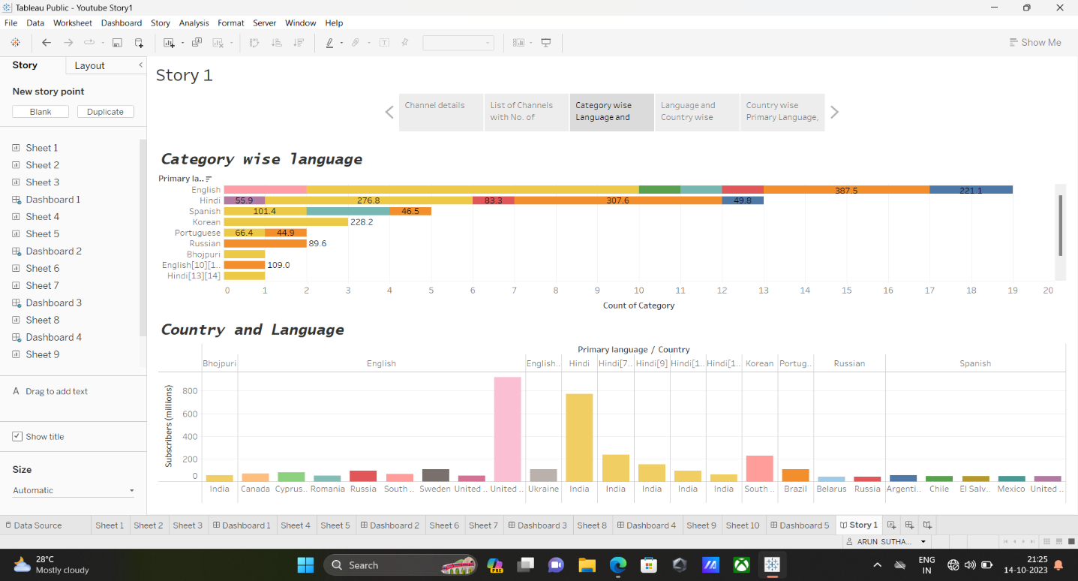

1. Advantages & Disadvantages
   1. Advantages of this Project

* Educational Value: This project serves as an educational resource, offering insights into the strategies and practices of successful YouTube channels. It can be a valuable learning tool for content creators, marketers, and those interested in the digital media landscape.
* Inspiration: It provides inspirational content for aspiring content creators, showing that with creativity, hard work, and the right strategies, anyone can find success on YouTube.
* Useful for Marketers: Marketers and advertisers can benefit from the project by gaining insights into the successful practices of top channels. This information can inform their advertising and partnership decisions.
* Community Building: The project emphasizes the importance of community engagement and interaction, teaching content creators and businesses about the value of connecting with their audiences.
  1. Disadvantage of this Project
* Biased Selection: There may be criticism if the project selects specific channels, potentially leaving out other deserving creators. It's essential to justify the selection criteria and be transparent about the choices made.
* Subjectivity: Profiles and interviews can be subjective, as the perception of success and the quality of content may vary from person to person.
* Changing Landscape: YouTube is an ever-evolving platform, and the strategies that work for success today might not be relevant tomorrow. The project may not provide the most up-to-date information, and success factors could change rapidly.
* Potential for Misrepresentation: If not conducted carefully, interviews and content analysis can misrepresent the creators or their work, leading to potential misunderstandings or controversies.

To maximize the advantages and mitigate the disadvantages, it's crucial to approach this project with transparency, objectivity, and a commitment to providing a well-rounded perspective on the world of YouTube.

1. Applications

* Education:
* Use the project as a teaching resource in media studies, marketing, and digital content creation courses.
* Create case studies based on the project for classroom discussions and assignments.
* Content Creation and Strategy:
* Content creators can gain insights into the strategies employed by top YouTube channels to improve their content and grow their audiences.
* Marketers and brands can use the project to understand successful advertising and sponsorship strategies on YouTube.
* Media and Journalism:
* Journalists and media professionals can use the project as a source of data and analysis for stories related to digital media, online content, and influential YouTube channels.
* Market Research:
* Marketers and businesses can conduct market research to identify trends and potential opportunities within specific niches on YouTube.
* Evaluate the competitive landscape and identify gaps where new content creators or businesses can thrive.
* Aspiring content creators can find inspiration and motivation by studying the stories and journeys of successful YouTubers.

1. Conclusion

The project, "Subscribers Galore: Exploring the World's Top YouTube Channels," represents an illuminating exploration of the dynamic and ever-evolving landscape of YouTube content creation. Through comprehensive channel profiles, creator interviews, content analysis, and insights into strategies for growth and engagement, the project reveals the inner workings of the world's most successful YouTube channels.

In conclusion, this project has achieved the following:

* Education and Inspiration
* Marketing and Business Insights
* Community Building and Engagement
* Cultural and Societal Impact
* Research and Analysis

This project exemplifies the influence of creativity, commitment and inventiveness, in the realm of content. It highlights the routes to achieving success the obstacles that creators encounter and the profound influence they can wield upon society. In a changing sphere this undertaking serves as a poignant reminder that YouTube persists as a platform where individuals and businesses can engage, enlighten and delight audiences worldwide.

In its entirety, "Subscribers Galore: Exploring the World's Top YouTube Channels" offers a comprehensive view of the world's top YouTube channels, and it is a valuable resource for those who wish to understand, learn from, and participate in the exciting realm of online content creation.

1. Future Scope

The future scope of the project, "Subscribers Galore: Exploring the World's Top YouTube Channels," is broad and promising, given the continually evolving nature of the online content creation and digital media landscape.

As the digital media landscape continues to evolve and new technologies and platforms emerge, the future scope of this project remains vast. By adapting to these changes and addressing the evolving needs of content creators, marketers, and researchers, "Subscribers Galore" can continue to be a valuable resource in the ever-expanding world of online content.